1.     # Book class to represent each book in the library

class Book:

    def __init__(self, book_id, title, author):

        self.book_id = book_id

        self.title = title

        self.author = author

        self.is_issued = False

    def __str__(self):

        status = "Issued" if self.is_issued else "Available"

        return f"ID: {self.book_id}, Title: '{self.title}', Author: {self.author}, Status: {status}"

2 # Library class to manage the collection of books

class Library:

def __init__(self):

self.books = []

def add_book(self, book):

self.books.append(book)

print(f"Book '{book.title}' added to the library.")

def remove_book(self, book_id):

for book in self.books:

if book.book_id == book_id:

self.books.remove(book)

print(f"Book '{book.title}' removed from the library.")

return

print(f"No book found with ID {book_id}.")

def list_books(self):

if not self.books:

print("No books in the library.")

else:

for book in self.books:

print(book)

def issue_book(self, book_id):

for book in self.books:

if book.book_id == book_id:

if not book.is_issued:

book.is_issued = True

print(f"Book '{book.title}' has been issued.")

else:

print(f"Book '{book.title}' is already issued.")

return

print(f"No book found with ID {book_id}.")

def return_book(self, book_id):

for book in self.books:

if book.book_id == book_id:

if book.is_issued:

book.is_issued = False

print(f"Book '{book.title}' has been returned.")

else:

print(f"Book '{book.title}' was not issued.")

return

print(f"No book found with ID {book_id}.")

3. # Create a library instance

library = Library()

# Add some books

book1 = Book(1, "The Great Gatsby", "F. Scott Fitzgerald")

book2 = Book(2, "To Kill a Mockingbird", "Harper Lee")

library.add_book(book1)

library.add_book(book2)

# List all books in the library

library.list_books()

and aftewr the cell run is:

Book 'The Great Gatsby' added.

Book 'To Kill a Mockingbird' added.

ID: 1, Title: 'The Great Gatsby', Author: F. Scott Fitzgerald, Status: Available

ID: 2, Title: 'To Kill a Mockingbird', Author: Harper Lee, Status: Available

4. # Remove a book by ID

library.remove_book(1)

# List books after removal

library.list_books()

and after the cell run

Book 'The Great Gatsby' removed.

ID: 2, Title: 'To Kill a Mockingbird', Author: Harper Lee, Status: Available

5. # Issue and return a book, then list books

library.issue_book(2)

library.list_books()

library.return_book(2)

library.list_books()

'library.list_books()'

6. # Add more books

book3 = Book(3, "1984", "George Orwell")

book4 = Book(4, "Pride and Prejudice", "Jane Austen")

library.add_book(book3)

library.add_book(book4)

# List all books to see the updated library

library.list_books()

and after the run cell is

Book '1984' added.

Book 'Pride and Prejudice' added.

ID: 2, Title: 'To Kill a Mockingbird', Author: Harper Lee, Status: Available

ID: 3, Title: '1984', Author: George Orwell, Status: Available

ID: 4, Title: 'Pride and Prejudice', Author: Jane Austen, Status: Available

# 

# Here are below some screenshots :

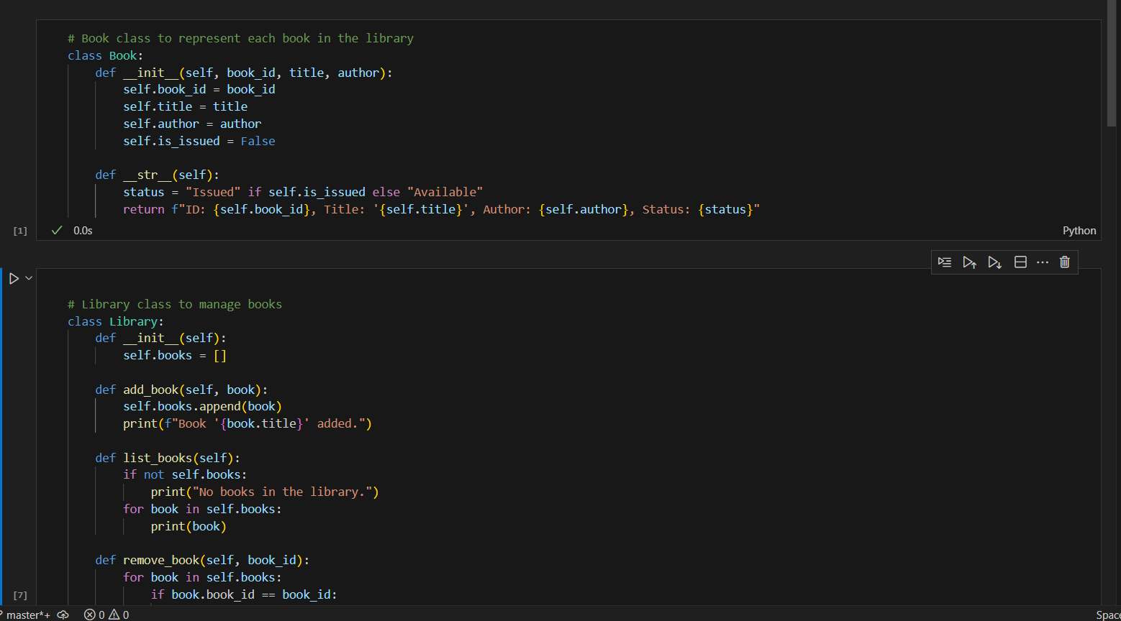

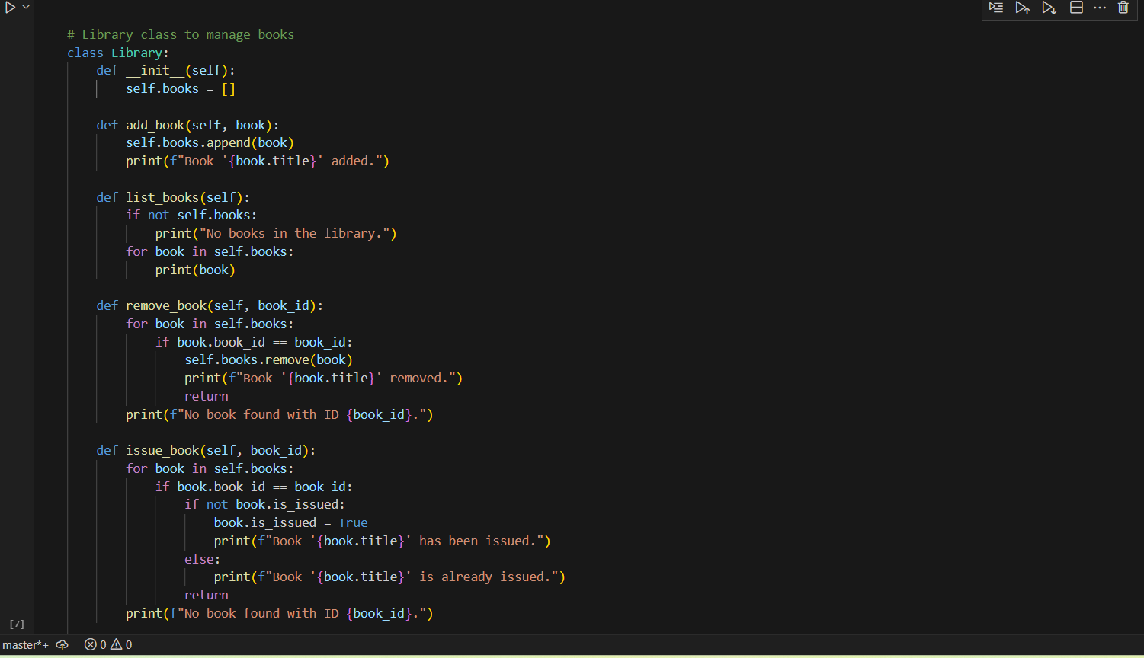

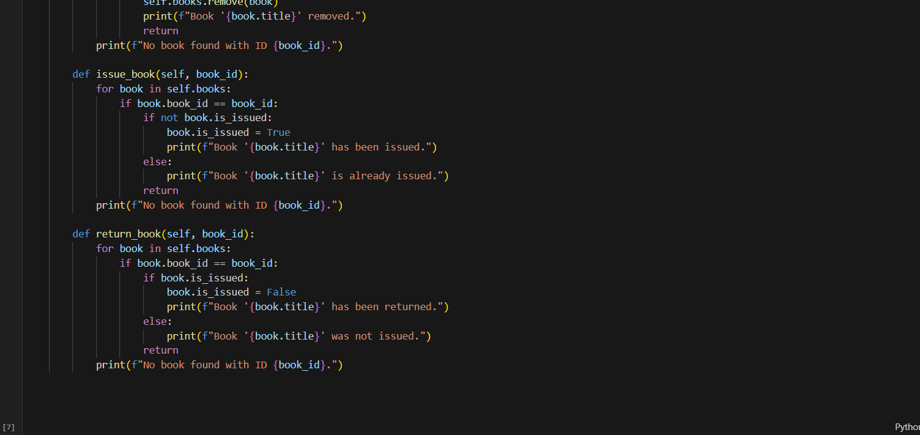

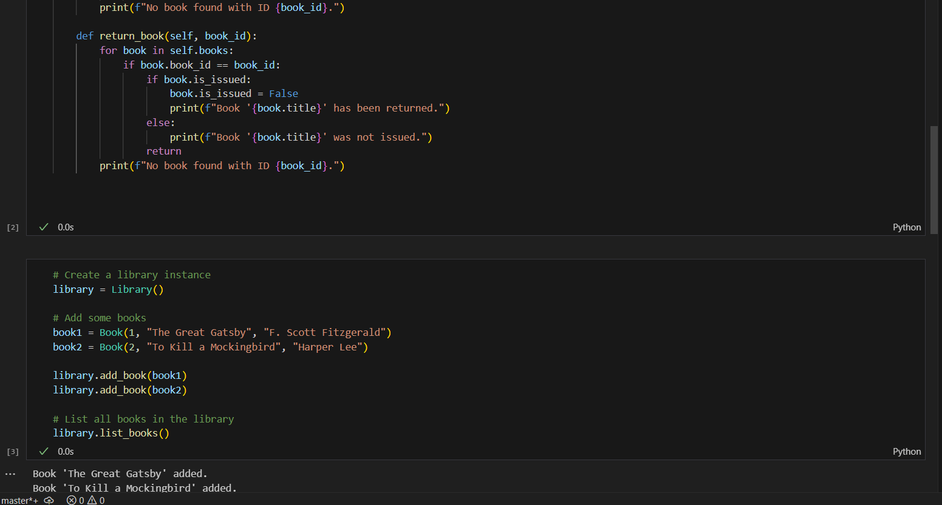

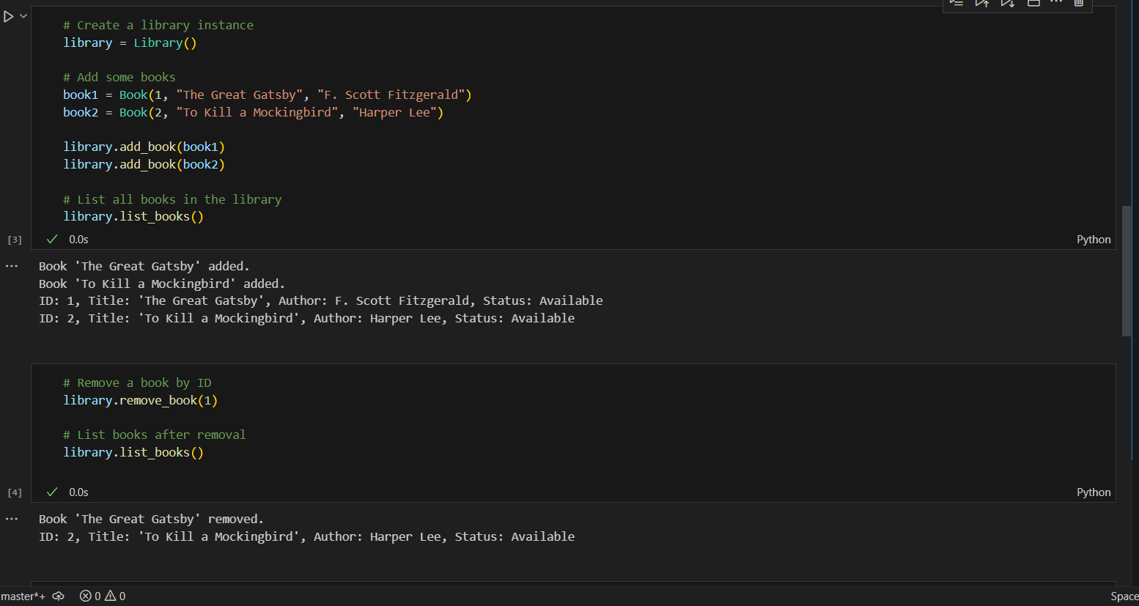

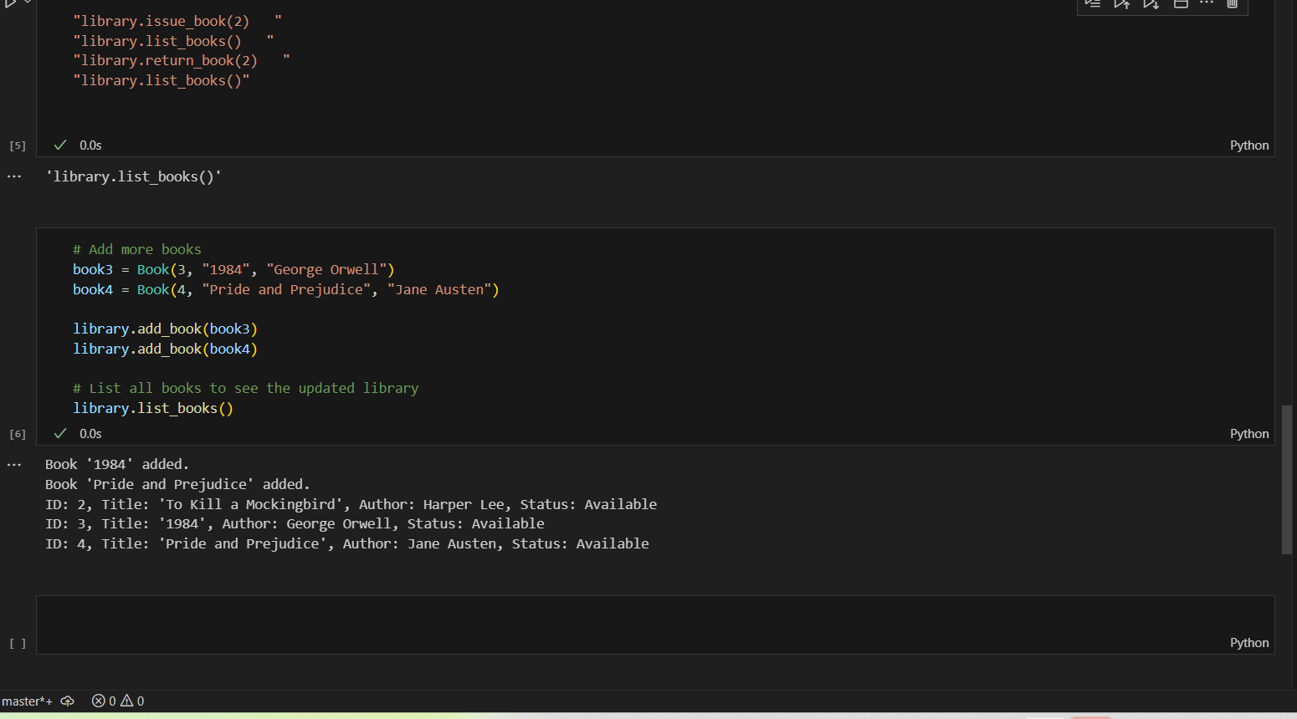

s